**Lir-NOTF ORE Industry Access Programme**

**Application for the Testing or Numerical Modelling of Marine Renewable Energy Devices and Technologies**

**CALL REMAINS OPEN UNTIL 18:00 on 9th May 2025**

**Contact Lir NOTF Facility Coordinator (m.zabihi@ucc.ie) when preparing application.**

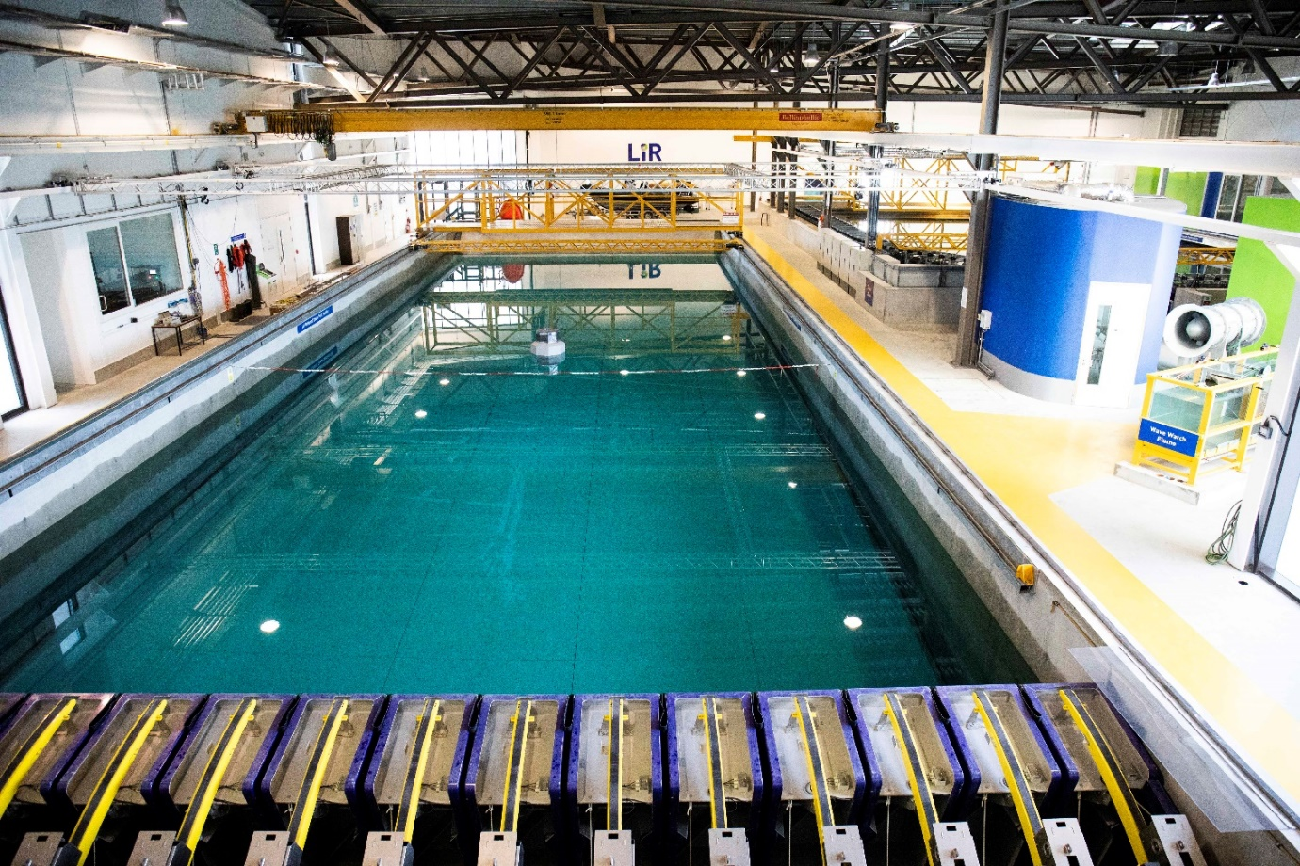

*Deep Ocean Basin at Lir NOTF*

**Completed application forms should be returned to Milad Zabihi by email (**[**m.zabihi@ucc.ie**](mailto:m.zabihi@ucc.ie)**) with all necessary documentation before 18:00 on** **9th May 2025**

**Introduction**

The Lir National Ocean Test Facility (Lir-NOTF) is Ireland’s primary facility for testing and development of offshore technologies and has a long track record in supporting offshore renewable energy (ORE) technologies through early stage TRL development. While fixed offshore wind technologies are commercially advanced, many offshore renewable energy (ORE) technologies that are required for deeper water and more aggressive environments are still in early stages of development. These technology developers usually consist of individuals, SMEs and academics who generally do not have the financial resources and expertise to determine the feasibility of their concept and require support. As a result, SEAI and Lir-NOTF have teamed up to offer this programme which will provide free access to the facilities of Lir-NOTF to Irish ORE developers defined as Irish registered companies, (including Irish subsidiaries of overseas companies based in the Republic of Ireland), where company staffing is consistent with Irish Company Registration Office requirements. This call is not open to sole traders.

This access programme to the Lir-NOTF is designed to enable the testing and progression of ORE technologies through the early development stages in advance of open sea testing. It is supported by SEAI and is open to any type of marine technology (wave, wind, tidal, floating solar, Energy conservation) that can be tested at the Lir-NOTF or **numerically simulated**.

*Figure 1 Six stage technology development process*

Therefore, applications are invited for the testing or numerical modelling of ORE concepts that can show efficient operations and survivability in Irish ORE sites and also can ultimately be beneficial to the Irish economy. These applications will be assessed by a Selection Panel (SP) comprising of experts in this sector.

Successful applicants will have access to one of the following facilities or equivalent use of equipment;

* Deep Ocean Basin
* Ocean Basin
* Wave and Current Flume
* Wave Watch Flume
* El Electrical laboratory / Energy laboratory
* Numerical Modelling

In this access programme, the applicant will be expected to supply the model and possibly some of the instrumentation for testing. The Lir-NOTF staff will check, setup and run all the tests and on completion will provide all the test data to the applicant.

**A detailed design in SolidWorks, or other accepted software, will need to be provided in the case of a numerical modelling application.**

Please note the following

* Applicants are required to contact the test facility to discuss proposed plans prior to applying.
* The maximum access that will be granted is two weeks of tank testing/ an equivalent amount of numerical modelling.
* All testing must be completed by end December 2025 with feedback submitted within two weeks post-testing.
* This programme is subject to EU State-aid rules. Further details can be found in the application guidelines.

More information can be found at ([www.lir-notf.com](http://www.lir-notf.com)) or by emailing Milad Zabihi ([m.zabihi@ucc.ie](mailto:m.zabihi@ucc.ie)). Please read the Application Guidelines before applying.

|  |  |
| --- | --- |
| **Group Details** | |
| **Project Leader details** (please enclose a Curriculum Vitae) | |
| **Title** |  |
| **Family name** |  |
| **First name** |  |
| **Country where applicant works** |  |
| **Phone number** |  |
| **Email** |  |
| **Company name** |  |
| **Company acronym** |  |
| **Position in company** |  |
| **Company postal address** |  |
| **Company country** |  |
| **Company website** |  |

|  |  |
| --- | --- |
| **Additional Group Member Details** | |
| Please enclose a Curriculum Vitae | |
| **Title** |  |
| **Family name** |  |
| **First name** |  |
| **Country where applicant works** |  |
| **Phone number** |  |
| **Email** |  |
| **Company name** |  |
| **Company acronym** |  |
| **Position in company** |  |
| **Company postal address** |  |
| **Company country** |  |
| **Company website** |  |
| Repeat table as necessary for **all other members of the group**. | |

|  |  |
| --- | --- |
| **Access Details** | |
| **Research infrastructure for which you are applying for access (see above list)** | |
| **Is this your only application in this call?** | Yes / No |
| If No, please give details: (approx. 100 words) |  |
|  | |

|  |  |
| --- | --- |
| **Length of time required for testing** |  |
| **Suggested start date** |  |
| **Details of any major timing constraints when you will be unable to test within the testing period (July-December 2025)** | |
|  | |

|  |  |
| --- | --- |
| **History** | |
| **Selection and eligibility** | |
| **New user**: have you ever used the proposed Research Infrastructure before? | Yes / No |
| **If Yes, please give details: (approx. 100 words)** | |
|  | |

|  |
| --- |
| **Description** |
| **Introduction: brief overview of your technology, including its development stage and how it addresses industry gaps or adds value to offshore renewable energy[1]** |
|  |
| **Do you have a model already fabricated or have you the capacity to do so? Give details (approx. 100 words)** |
|  |

|  |
| --- |
| **Objectives of the proposed work:** What do you expect to gain out from testing - these can be classified according to primary and secondary goals and include commercial benefits/progress |
|  |

|  |
| --- |
| **Outline the test plan (including set up time, different configuration, wave condition, demobilization, etc)** It is important that the scope of work is clearly focused with defined primary and secondary objectives. Please contact the facility you intend to test at before commencing this section. Contact details are in the Application Guidelines. |
|  |

|  |
| --- |
| **Specific requirements** - include details of **tentative equipment/instrumentation/materials required** (subject to what is offered by the infrastructure - see infrastructure description), technical assistance and training required etc. |
|  |

|  |
| --- |
| **Intellectual Property** – is the technology patented? Discuss capacity to share data/knowledge arising from the testing. |
|  |

|  |
| --- |
| **Outline the potential impacts of proposed testing (scientific, commercial, environmental) (approx. 100 words)** |
|  |

|  |
| --- |
| **Relevance and potential benefits to Ireland**  Indicate technology development strategy and commercialisation pathway and how it will help meet Ireland’s energy objectives and benefit the Irish supply chain **(approx. 300 words)** |
|  |

1. Please attach up to two images of the device being submitted for testing. Images must be in JPEG or PNG format only. Videos of the model demonstrating the working principle(s) can also be submitted.